Mainframe Assist + ZOAU: Technical Architecture Blueprint
Sep 29, 2026 ·

Purpose and scope
Add IBM Z Open Automation Utilities (ZOAU) to Mainframe Assist as an optional, read-only evidence collector first, and keep every write on the existing z/OSMF path until security review approves more.
The goal is better diagnosis: ZOAU can check what actually exists on the LPAR (members, dataset attributes, catalog and VSAM state) instead of the agent inferring it from spool text alone.
In scope: where ZOAU sits, how the bridge reaches it, the collector contract, the trust model, deployment impact and a phased rollout. Out of scope: replacing z/OSMF, changes to the UI, pricing, and Track B modernization.

Current architecture baseline
Today exactly one service touches the mainframe: autofix-bridge, over z/OSMF REST through Zowe CLI v2. This blueprint keeps that true for every write.
Component | Runs on | Role today
lucent-ui | Cloud Run (Next.js) | Operator UI: incidents, proposed fixes, approvals
autofix-orchestrator | Cloud Run (Python) | Control plane: owns Firestore and GCS, about 45 REST endpoints, plan gate, collision guard
autofix-bridge | Private Cloud Run | Only service that reaches z/OS; 3-worker agent loop; Zowe CLI v2 to z/OSMF for submit and verify
incident-intake | Cloud Run | Brings abend incidents into the loop
Agent model | Azure AI Foundry (Sweden Central) | Claude Sonnet 4.5 for diagnosis and fix proposals; swappable by design
z/OS | Client LPAR | z/OSMF REST: jobs, spool, datasets
The closed loop is detect, diagnose, propose, human approval, apply, resubmit, verify. Every write action is gated by a person.

Key constraint
ZOAU runs inside z/OS UNIX System Services on the LPAR, so the bridge on Cloud Run cannot import or call it directly.
Using ZOAU therefore needs a second path from the bridge into USS, in addition to z/OSMF REST. Every other decision here follows from that: the transport, the service ID's permissions, the security review and the client prerequisites.
Two consequences shape the design:
- ZOAU must stay optional. A client LPAR without it, or without SSH approval, still gets the full loop over z/OSMF.
- The new path starts read-only. It adds evidence without adding a new way to change the mainframe.

Target architecture
The bridge keeps its z/OSMF path for everything it does today and gains one new, read-only SSH call to a collector on the LPAR.
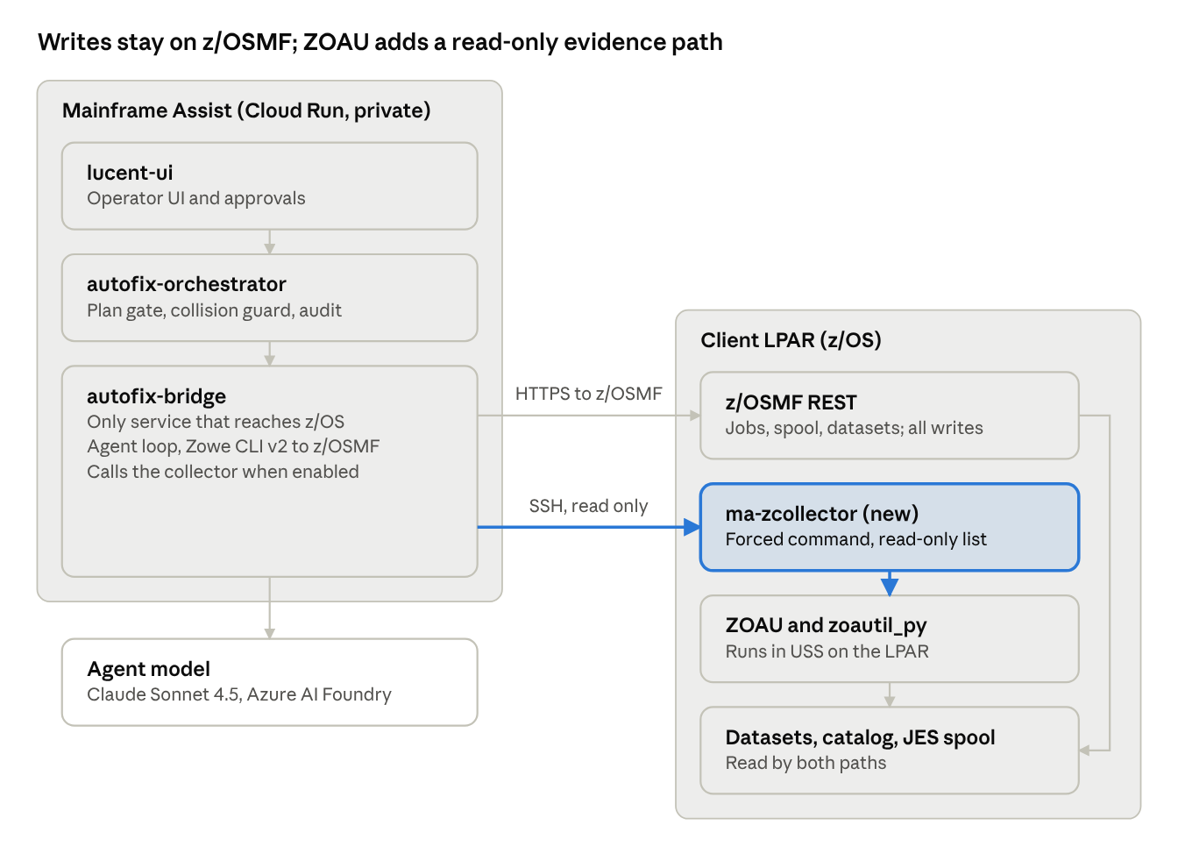
target architecture · existing z/OSMF path plus the new read-only collector path
The highlighted path is new. Every arrow into z/OS still starts at autofix-bridge, so the bridge stays the single service that touches the mainframe.
Transport options for the new path
Option | How it works | Trade-off
A. Zowe CLI over SSH | Bridge runs zowe zos-uss issue ssh with ZOAU CLI commands and parses text output | No code on the LPAR, but a general shell and fragile text parsing
B. Collector with forced command (recommended) | Bridge sends one JSON request over SSH; the key can only start ma-zcollector, which returns JSON | Needs a small install on the LPAR, but the command set is fixed and output is structured
Option B is recommended because the allow-list is enforced on the mainframe side, which is what a client security team will ask for.

Capability mapping by loop stage
Diagnosis gains the most from ZOAU; detection gains almost nothing, and fixes are already possible over z/OSMF.
Stage | Today over z/OSMF | ZOAU adds | ZOAU CLI | zoautil_py | Phase
Detect | JES spool polling via REST | Little; keep z/OSMF | jls | jobs.listing | Not planned
Diagnose | Spool text plus the abend knowledge vault | Proof of what exists: members, dataset attributes and space, catalog and VSAM state | mls, dls -l, mvscmd running IDCAMS LISTCAT | datasets.list_members, datasets.list_datasets, mvscmd.execute | 1
Propose | Agent reasons over the evidence | Structured evidence the proposal can cite | n/a | n/a | 1
Apply | Writes through z/OSMF after approval | Utility fixes without JCL: allocate with the right DCB, copy, in-place edit, GDG base or VSAM define | dtouch, dcp, dsed, mvscmd | datasets.create, datasets.copy, mvscmd.execute | 2, if approved
Verify | Resubmit and check the return code | Read output DDs and check output dataset contents on the LPAR | jsub, pjdd, dls | jobs.submit, jobs.read_output, datasets.read | 1 for reads
ZOAU command and function names differ slightly between versions. Confirm each against the client's installed ZOAU before building the allow-list.

Worked example: S013 on EODBATCH
In the demo abend, ZOAU turns an inferred root cause into a proven one by listing the members that actually exist.
The demo job EODBATCH abends S013 because JCL names member SORTR7 while the library holds SORTR07. Today the agent reads that from spool messages and the vault. With the collector:
- The bridge reads the failing DD and dataset name from the spool over z/OSMF, as it does now.
- It asks the collector for list_members on that library.
- The collector returns the member list as JSON: SORTR7 is absent, SORTR07 is present.
- The proposal cites that evidence: change SORTR7 to SORTR07 in the JCL.
- A person approves, and the fix is applied and the job resubmitted over z/OSMF, unchanged from today.
- On verify, the collector can confirm the step's output dataset was written.
The library name comes from the spool at run time; this document does not assume one.
z/OSMF REST can also list PDS members, so this particular check works without ZOAU. ZOAU earns its place on the checks z/OSMF handles poorly: catalog and VSAM state through IDCAMS, full dataset attributes, and several checks batched in one call.

Evidence collector contract
The collector is a small Python program on the LPAR, using zoautil_py, that accepts one JSON request, runs only allow-listed read operations, and returns JSON evidence.
Proposed working name: ma-zcollector. It lives in a read-only USS directory owned by the client's systems team, not by the bridge.
Phase 1 allow-list (read only)
Operation | Backed by | Returns
probe | ZOAU version check | ZOAU and Python versions, collector version
list_members | datasets.list_members | Member names for a PDS or PDSE
dataset_info | datasets.list_datasets | DSORG, RECFM, LRECL, BLKSIZE, space, volume
listcat | mvscmd.execute with IDCAMS LISTCAT | Catalog entry, VSAM cluster and GDG base details
read_output | jobs.read_output | One DD from a job's spool
read_head | datasets.read | First N records of a dataset, N capped
Request and response
{
"request_id": "inc-000123-ev-02",
"op": "list_members",
"args": { "dataset": "<library from spool>" }
}

{
"request_id": "inc-000123-ev-02",
"op": "list_members",
"ok": true,
"evidence": { "members": ["SORTR06", "SORTR07"] },
"exit_code": 0,
"duration_ms": "<ms>",
"collector_version": "<semver>",
"raw_sha256": "<hash of the raw ZOAU output>"
}
The member names above are illustrative. Any operation not on the list returns ok: false with error: "op_not_allowed" and runs nothing.
Detection and fallback
- On LPAR onboarding, the bridge runs probe and the orchestrator stores a zoau_enabled flag on the LPAR record.
- zoau_enabled false, a failed probe, or a collector timeout means the bridge uses z/OSMF only for that incident and records why.
- The collector never blocks the loop: evidence it cannot get is marked missing, not guessed.

Security and trust model
The SSH path is locked to one command, one read-only identity and one allow-list, so it cannot become a general shell onto the mainframe.
Control | Design
Identity | A separate RACF service ID for the collector, not the bridge's z/OSMF ID; OMVS segment required
Dataset access | READ only on the libraries and catalogs the client names; no UPDATE or ALTER in phase 1
Authentication | SSH key only, private key in the bridge's secret store, never on disk in the image
Command lock | authorized_keys forced command runs ma-zcollector only; no interactive shell, no port forwarding
Allow-list | Enforced inside the collector; unknown operations run nothing
Input handling | Dataset and member names validated against z/OS naming rules before any call
Writes | None over SSH in phase 1; all changes stay on z/OSMF behind the approval gate and collision guard
Audit | Every request and response logged by the orchestrator with request ID, operation, exit code and output hash; the collector also logs locally on the LPAR
Network | Bridge egress to the LPAR's SSH port only, from the private Cloud Run service
What the cybersecurity review must cover
- SSH as a second route onto the LPAR, alongside z/OSMF.
- The collector's RACF profile and the list of datasets it can read.
- Key storage, rotation and revocation.
- Whether collected evidence, such as dataset contents from read_head, is sent to the hosted model, and how it is minimised.

Deployment and portability impact
ZOAU is an add-on per LPAR, never a prerequisite, so the Assist-Anywhere portability plan and the BYOC tiers stay intact.
Client prerequisites when ZOAU is enabled
- ZOAU and a supported IBM Python on the LPAR. As far as we know ZOAU is offered at no extra charge to z/OS licensees; confirm per client.
- SSH enabled for USS, reachable from wherever the bridge runs.
- The collector service ID, RACF profile and forced-command key set up by the client's systems team.
Commercial tier | ZOAU position
Shadow-mode pilot (hybrid connector) | Off by default; the pilot runs on z/OSMF alone. Offer the collector as an opt-in during the pilot.
BYOC managed | Optional per LPAR; the bridge runs in the client's cloud, so SSH stays inside their network boundary
Sovereign single-VM on-prem | Best fit: the bridge and LPAR share a network, and the collector adds no new egress
The PostgreSQL port that replaces Firestore is unaffected: the zoau_enabled flag and evidence records are ordinary rows.

Phased rollout
Phase 1, read-only evidence, is the target; phase 2 happens only if both the security review and the accuracy benchmark support it.
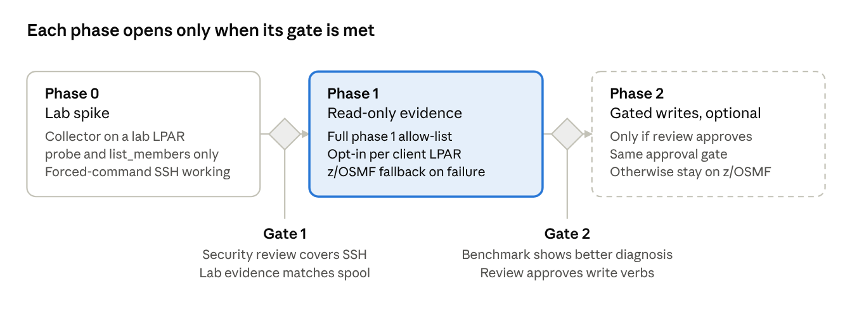
rollout · 3 phases, 2 gates, no dates set
No dates are set here; they depend on the cybersecurity review timeline and access to a lab LPAR. Gate 2 uses the accuracy benchmark harness already planned for Mainframe Assist, comparing diagnoses with and without collector evidence.

Risks, open questions and decisions
The largest risk is the security story: a second route onto the LPAR must not slow client procurement.
Risk | Mitigation
Clients refuse SSH to USS | ZOAU stays optional; the full loop runs on z/OSMF
ZOAU version differences break calls | probe records versions; the allow-list maps to tested versions only
Collector drifts into a write path | Writes stay out of the collector until phase 2 is approved; code review enforces the allow-list
Dataset contents leak to the hosted model | read_head capped and off by default; evidence minimised before the model call
Two paths make incidents harder to trace | One request ID across z/OSMF and collector calls, logged by the orchestrator
Open questions
- ☐ Do the target clients already run ZOAU on their LPARs?
- ☐ Will Dexian cybersecurity review the SSH path in the current assessment or a separate one?
- ☐ Which abend classes in the vault would use collector evidence first?
- ☐ Should phase 2 writes ever move to ZOAU, or stay on z/OSMF permanently?
Decisions needed
- ☐ Approve phase 1 as read-only, optional, per LPAR.
- ☐ Name an owner for ma-zcollector and its allow-list.

